Name:

Yr 9 Physical Science:
Light Experiments

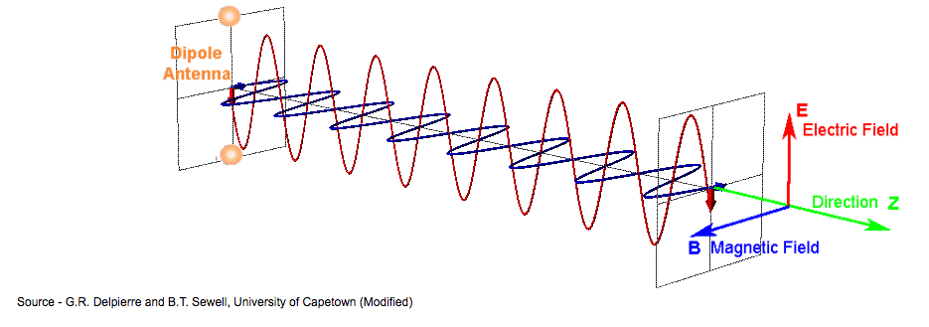

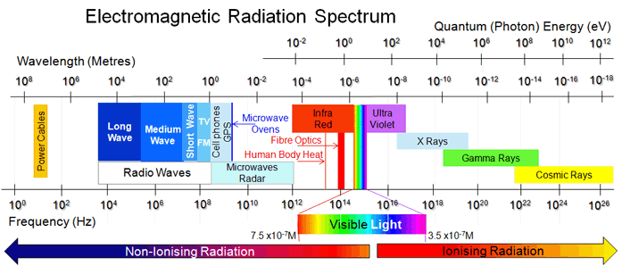

OBJECTIVES

At the end of this unit you will be able to:
- Recall that waves carry energy but not matter
- Recall that light is part of the electromagnetic spectrum.
- Recall that light has ‘wave like’ properties.
- Recall that light travels at 300 000 000 ms⁻¹, as do all EM waves
- Explain the Law of Reflection (angle of incidence = angle of reflection)
- Describe how light is reflected by concave and convex mirrors
- Describe everyday uses of concave and convex mirrors
- Explain the refraction of light in various situations, understanding under which conditions light refracts towards the normal and which conditions it refracts away from the normal
- Discuss the phenomenon of total internal reflection of light and its uses
- Compare the effects of concave and convex lenses on light and explain how they form images
- Describe how white light can be split into its constituent colours (dispersion)

ASSESSMENT

The assessment for this topic includes

- Research task on the uses of radioisotopes
- Quiz

Students are also required to complete all work in this booklet as part of this unit.
This booklet will be assessed on the following criteria:
C1: Independently and collaboratively completes tasks and meets deadlines
C3: Processes, analyses and evaluates data and information
C6: Understands and applies knowledge
GLOSSARY

Please complete this glossary as you work through this unit. You will be expected to know the definitions of these words for the topic test.

Incident Ray: _____________________________________________________
Reflected Ray: _____________________________________________________
Normal: _____________________________________________________
Refraction: _____________________________________________________
Total Internal
Reflection: _____________________________________________________
Critical Angle _____________________________________________________
Specular Reflection____________________________________________________
Diffuse Reflection ____________________________________________________
Focal Point: _____________________________________________________
Refracted Ray: _____________________________________________________
Convex Mirror: _____________________________________________________
Concave Mirror: _____________________________________________________
Convex Lens: _____________________________________________________
Concave Lens: _____________________________________________________

LIGHT and THE ELECTROMAGNETIC SPECTRUM

The light that we see is only a small part of a much larger spectrum known as the electromagnetic spectrum. Unlike sound and water waves, light and all waves that are a part of the electromagnetic (EM) spectrum are transverse waves.

The electromagnetic spectrum is shown below. Each part has it own special properties and uses. Note that just like the colours of light, there is no clear boundary between regions in the spectrum (that is why it is called a spectrum).
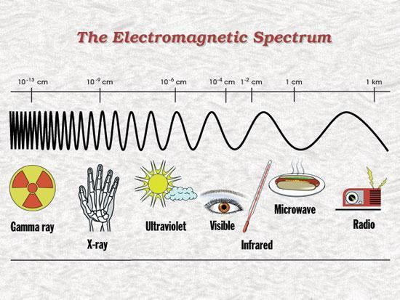
All EM waves share the following properties:
- They transfer energy from one place to another.
- They are all transverse waves.
- They can all be reflected.
- They can all travel through a vacuum.
- They all travel at the speed of light (300 000 000 ms⁻¹ ).
- They all obey the wave equation (v = f ⋅ λ).
- The shorter the wavelength, the more dangerous they are.
A MODEL FOR LIGHT

Scientists have studied the phenomenon of light for many hundreds of years. There have been many theories about light… some of them very wrong., and some of them quite close to the truth.
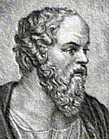

Plato
Some of the ancient Greek philosophers believed that light consisted of tiny particles which would enter the eye and allow us to ‘see’. Others, like Plato and Socrates thought that we could see because ‘streamers’ or ‘filaments’ were emitted by the eye and made contact with the object we were looking at. This view was supported by another famous philosopher, Euclid, who said that this explained why we didn’t see an object on the floor until our eyes ‘fell upon the object’.

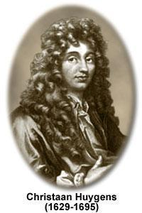
Up until the time of Newton and for a few hundred years after, scientists thought that light did consist of particles.
A contemporary of Newton, a Dutch Scientist - Christian Huygens believed that Light was a wave. Many scientists argued both cases – light as a particle and light as a wave.

In 1905 Einstein published a famous paper on the Photoelectric Effect and from this, the term photon was introduced. Light was said to be small bundles of mass less bundles of concentrated energy or photons.

Scientists now agree that light has a dual nature. Light behaves like a wave and like particles. If you would like to investigate this further, there are two good minute physics videos available on youtube:
- https://www.youtube.com/watch?v=Q_h4IoPJXZw and
- https://www.youtube.com/watch?v=_riIY-v2Ym8

Light travels in straight lines. We say that it is ‘rectilinear’. Because light travels in straight lines, shadows are formed. We also know that light travels in straight lines because we cannot see around corners.

When we do experiments with light, we often use one very narrow beam of light called a ray. We draw a ray as a straight line from the light source.

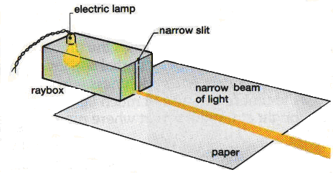

The use of rays to depict what light is doing is the most common way of modelling the behaviour of light. The straight line is a simple way in which to depict what light does (travels in straight lines). There are, however some problems that are associated with the ‘ray model’ but these will not be discussed at this year level.

When drawing ray diagrams, you should always use a sharp pencil and a ruler. Your teacher will demonstrate how to draw a good ray diagram.
THE SPEED OF LIGHT

For many years, scientists thought that the speed of light was ‘infinite’; that it’s speed was unmeasurable. Galileo proposed an experiment to measure the speed of light. It wasn’t until many years after Galileo (Galileo lived between 1576 – 1642) that Albert Michelson measured the speed of light accurately.

Find out how Galileo, and later Michelson, attempted to measure the speed of light.

Michelson’s method is a little complicated, but he found that light travelled at
300 000 000 ms⁻¹ or 300 000 kms⁻¹. This is obviously very, very fast. Scientists give the speed of light a special letter – the letter ‘c’. This is the ‘c’ in Einstein’s very famous equation, E = mc².

It takes light some minutes to travel to us from the sun. You can work out how far the sun is from the earth using this information.
Time for light to travel to the earth from the sun = minutes
= ⋅ 60 = 500 seconds
Speed of light = 300 000 00 m/s
To determine the speed of anything, what measurements must you make?
Draw a diagram to show Galileo’s method for measuring the speed of light . Clearly indicate the measurements that needed to be taken in order for this method to succeed.
Why didn’t Galileo’s method succeed?
How long would it take light to travel the two miles (3.4 km) as suggested by Galileo?
so distance = speed ⋅ time
= 300 000 00 ⋅ 500
= 150 000 000 000 metres
= 150 000 000 km

WORKSHEET #1

- The speed of sound in air is about 340 ms⁻¹. Approximately how many times faster than the speed of sound is the speed of light? Show your calculations.

- Light takes about 8 minutes to reach the earth from the Sun. How long does it take light to travel from the sun to

  - Mars (228 000 000 km)

  - Pluto (5 900 000 000 km)

HINT: Don’t forget to convert the distances to metres if you are using the speed of light in ms⁻¹ .

- If it takes light 193 seconds to travel from the sun to Mercury, how far is Mercury from the Sun?

- All waves obey the wave equation, v = f ⋅ λ. Given that v = 300 000 000 ms⁻¹ for light (and all waves that are part of the EM spectrum), determine the frequency for red light if its wavelength is 0.00000065 m.

- Is light a wave or a stream of particles? What do scientists think?

____________________________________________________________________________________________________________________________________________________________________________________________________________________________________________________________________________________________________________________________________

- List the EM spectrum in order from largest wavelength to smallest wavelength.
__________________________________________________________________________________________________________________________________________________________________

- What seven properties do all waves on the EM spectrum share?

____________________________________________________________________________________________________________________________________________________________________________________________________________________________________________________________________________________________________________________________________

Experiment #1

Law of Reflection

Aim
To investigate the reflection of light beams

Equipment
- Light box
- Single Slit
- Power packs
- Plane Mirror

Method
- Place a plane mirror on the diagram below as indicated.
- Shine a single beam into the mirror at an angle of 70°. Draw both the incoming (incident) ray and the reflected ray accurately on the diagram. You will need to make sure that the light beam is narrow and focussed. If it spreads out too much, use the opposite side of the light box.
- Show the direction of the light rays with an arrow and label the incident and reflected rays with the number ‘1’.
- Note the line perpendicular to the mirror where the light hits the mirror. This is called the normal (N).
- Measure the angle of reflection(r), the angle between the normal and the reflected ray.
- Repeat the above experiment for four more different incident rays of varying angles.

Results
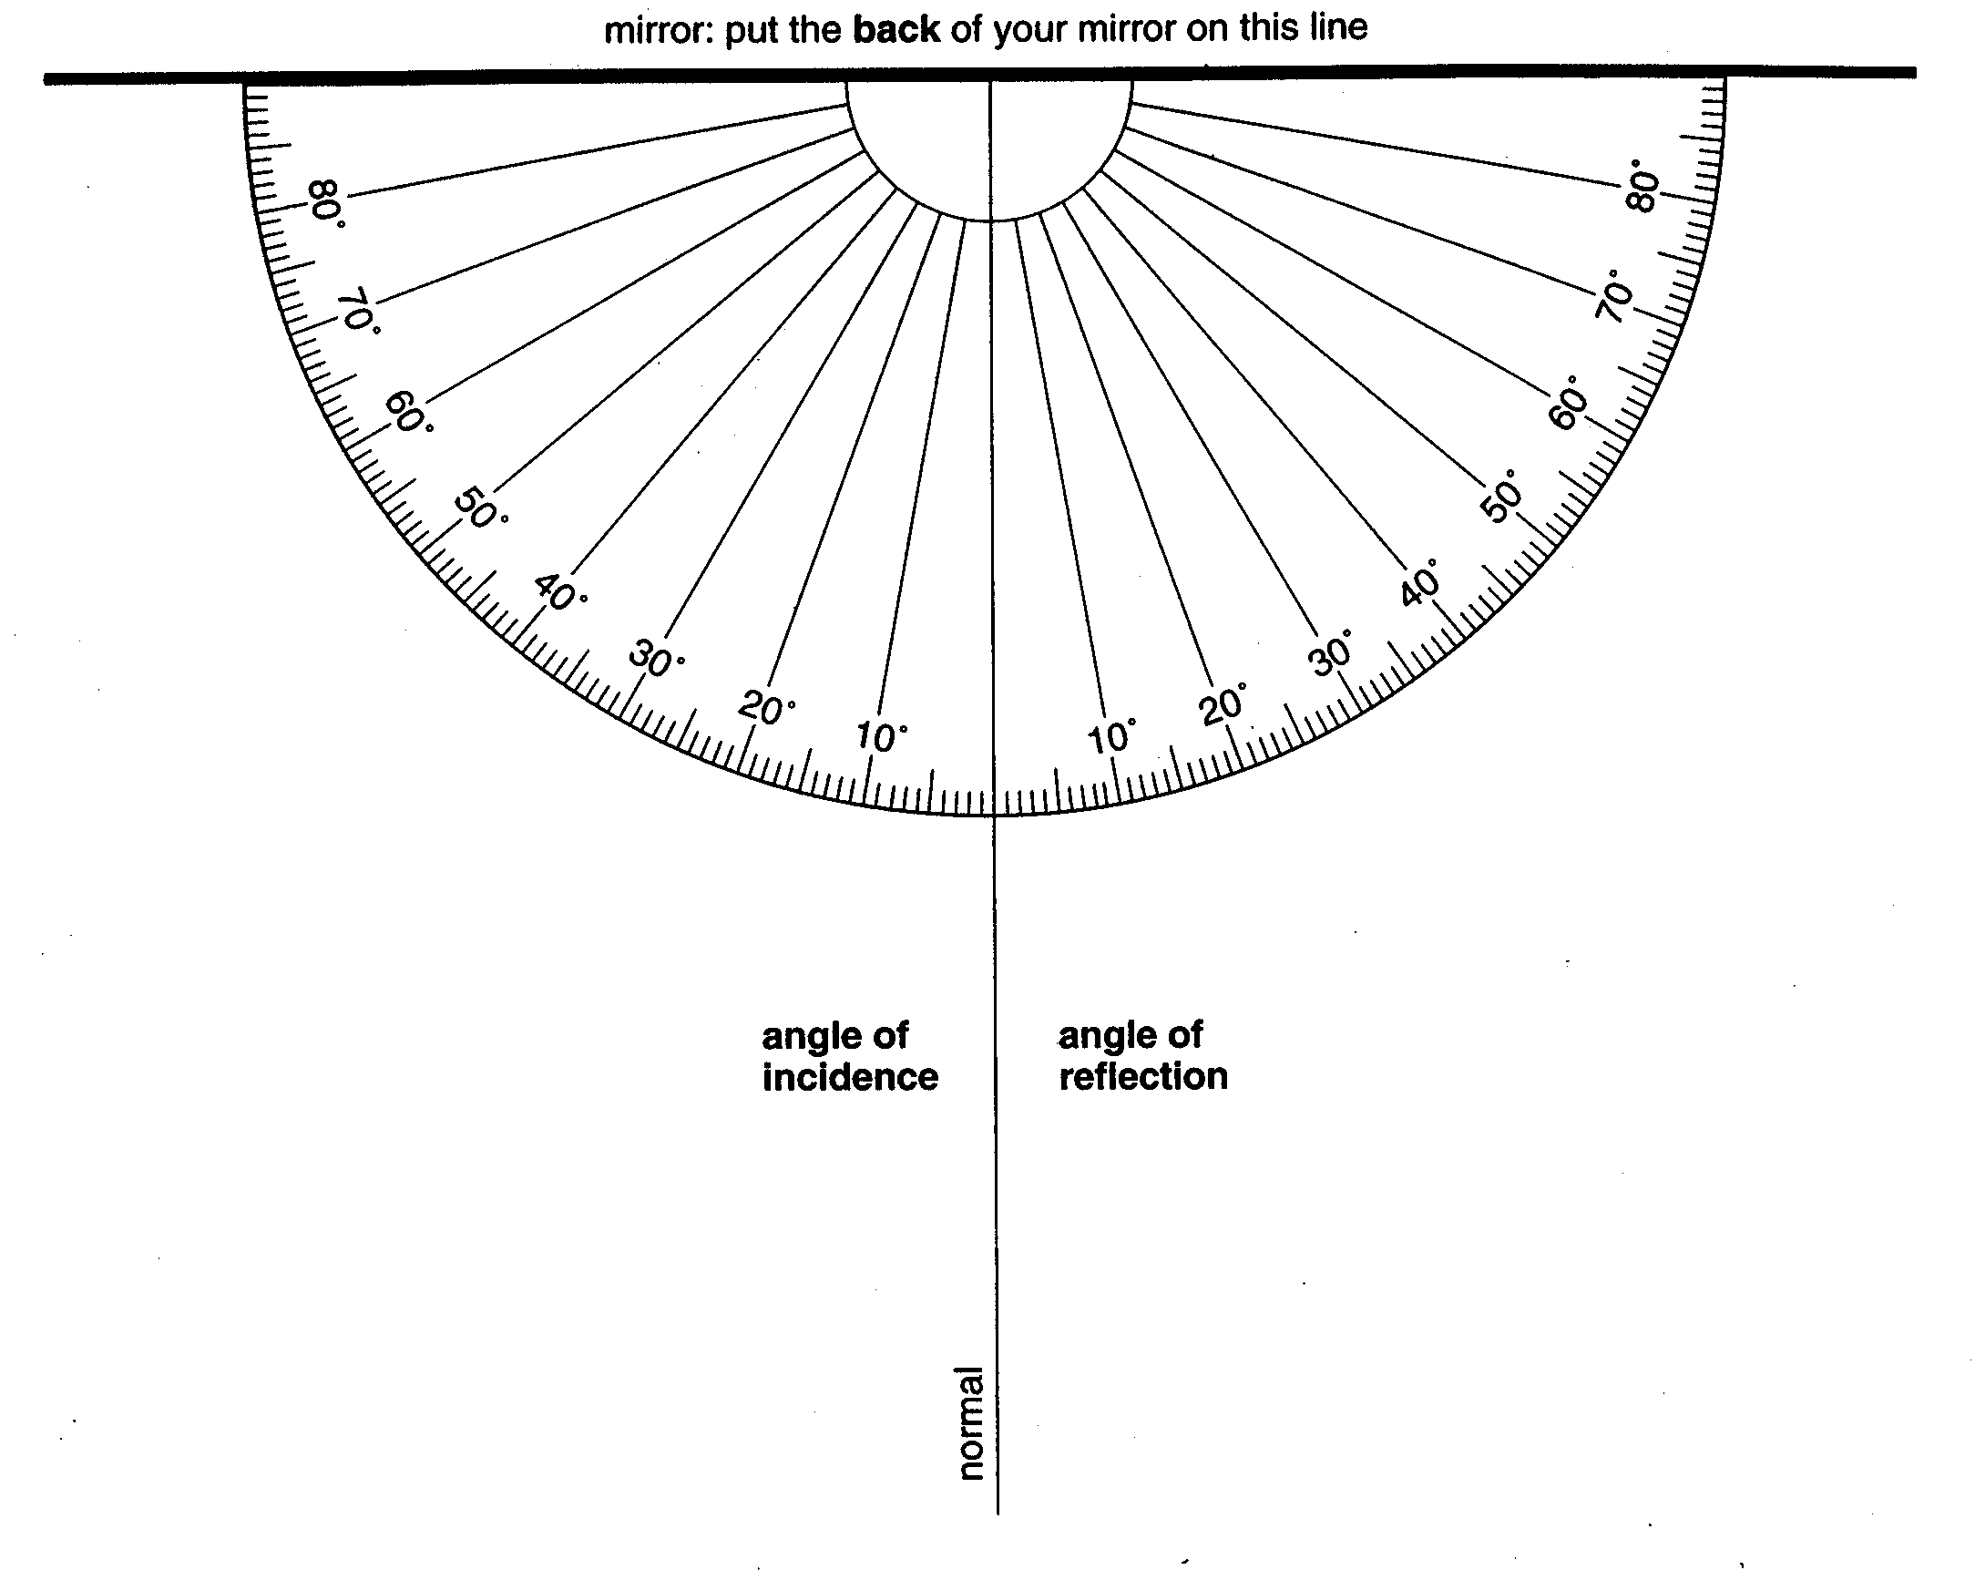
Angle of Incidence  i | Angle of Reflection  r

Conclusion

______________________________________________________________________________________________________________________________________________________________________________________________________________________________________________________________________________________________________________________________________________________________________________________________________________________________________________________________________________________________________

THE LAW OF REFLECTION

The law of reflection states that

the angle of incidence = the angle of reflection

This law can be applied to all waves, including all of the different parts of the electromagnetic spectrum.

As we have studied previously, water waves and sound waves also reflect and these waves also obey the law of reflection.

SPECULAR and DIFFUSE REFLECTION

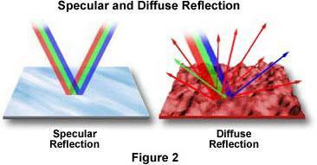
Some surfaces seem much better suited to producing a high quality reflective image. Mirrors are designed to do just that. However, you have probably also seen your own reflection in some other surfaces, like in water (a lake) or in shiny metal surfaces.

Shiny surfaces produce ‘specular reflection’. This is reflection where the light reflects in a very ordered manner. The light from an object is reflected from the surface and travels to your eye, so you can see the image.

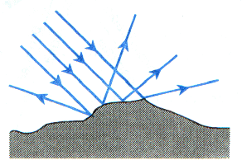
Reflection of light of your page is called diffuse reflection. The light rays are scattered because of the type of surface (rough) that the light is incident on. The surface may appear to be smooth, but viewed under a microscope the surface is very uneven (as shown in the diagram ). We do not see images in these types of surfaces because the light comes from the object, hits the surface and scatters, with only some of it entering our eye.

Note that in all of the reflection discussed, the Law of Reflection still holds. If you drew in a normal line (at right angles to the surface) then you would find that angle of incidence does equal the angle of reflection.

WORKSHEET # 2

- Clearly label the following diagram, using the following words:
  - Normal
  - Incident ray
  - Reflected ray
  - Angle of incidence
  - Angle of reflection
  - Mirror

- A periscope can be used to see above the water in a submarine. The diagram below shows the outline of the periscope and light rays entering the periscope from above the water level.
light rays

eye
SEA
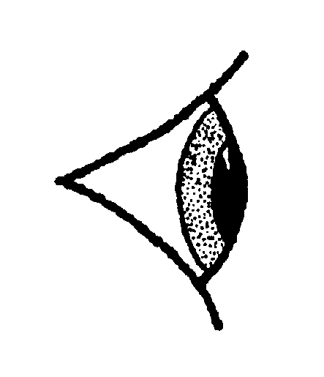

On the diagram continue the light rays until they enter the eye. Use a sharp pencil and a ruler.

3. Look carefully at the diagram to the right.

Without using a protractor,

40

a) What is the angle of incidence?

b) What is the angle of reflection?

EXPERIMENT # 2
CURVED SURFACE REFLECTIONS

Aim
To investigate the reflection of light beams from curved surfaces – convex and concave mirrors.

Equipment
- Light box
- Triple Slit
- Power packs
- Convex and Concave Mirrors

Method

Identify which mirror is a concave mirror and which is a convex mirror. Label the diagrams below appropriately.

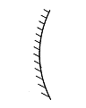 | 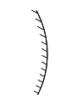
Name : _________________________ | Name : _________________________

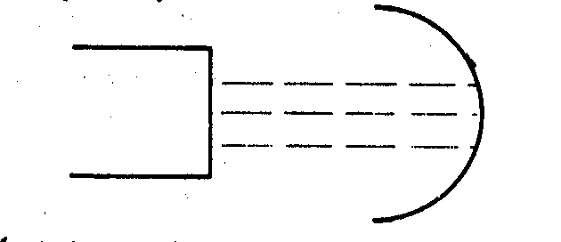
- Shine three rays of light onto a concave mirror and clearly record your results.

- Shine three rays of light onto a convex mirror and clearly record your results.

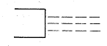

- When using a concave mirror, the rays of light are reflected and brought together at a point. This point is known as the focal point. Draw out you results again for the concave mirror and clearly mark in the focal point.

- When using a convex mirror, the rays of light are reflected and appear to have come from a point behind the mirror. This point is known as the focal point. Draw out you results again for the convex mirror and clearly mark in the focal point.

- What happens if a mirror is used that has a smaller curve? What will happen to the position of the focal point? Try this, and record your results below for both a convex and a concave mirror. Make a short statement summarising your findings.

_________________________________________________________________________________________________________________________________________________________________________________________________________________________________________________________________________________________________________________________________

Overall Conclusion on Curved Surface Reflection

____________________________________________________________________________________________________________________________________________________________________________________________________________________________________________________________________________________________________________________________________
CURVED MIRRORS

The laws of reflection that we met earlier are still relevant even though we are now dealing with curved surfaces. In fact, a curved mirror can be thought of as a series of plane mirrors being used together.

i.e.

Here, each plane mirror has a normal, and by applying the law of i = r, you will find that the light will behave as if we were using a curved mirror.

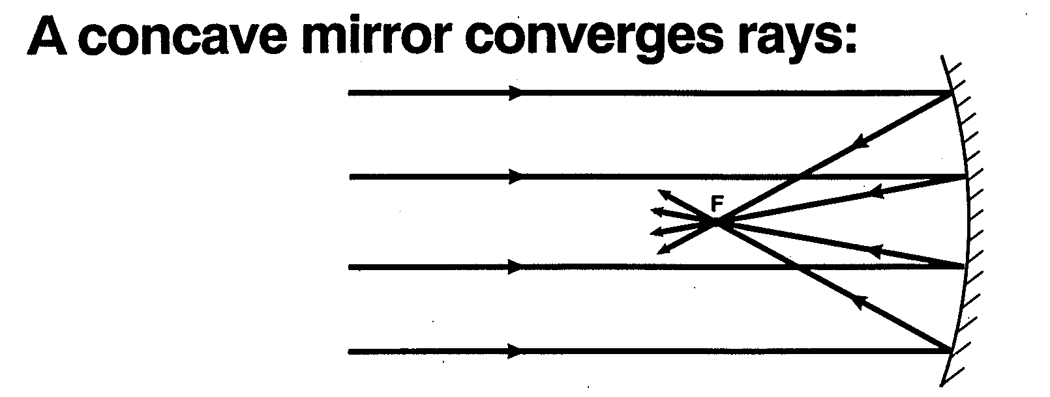
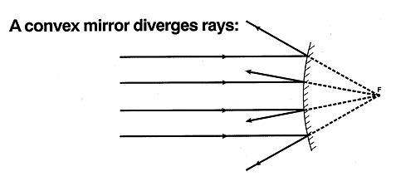
WORKSHEET # 3

- The diagram below shows a plan view of a ray of light striking a plane mirror.



normal

ray of
light

mirror

(a) On the diagram draw the ray of light after it is reflected off the mirror.

(b) For the following sentences chose words from the list below:

Smaller, the same size, larger, real, virtual, inverted, the same way up.
You may need to use your text book to help you out.

“The size of the reflected image is _________________________ when compared to the object.”

“The orientation of the reflected image is _______________ when compared to the object.”

“The type of image is said to be ________________________________________.”

- The diagram below shows an object placed in front of a bathroom mirror.
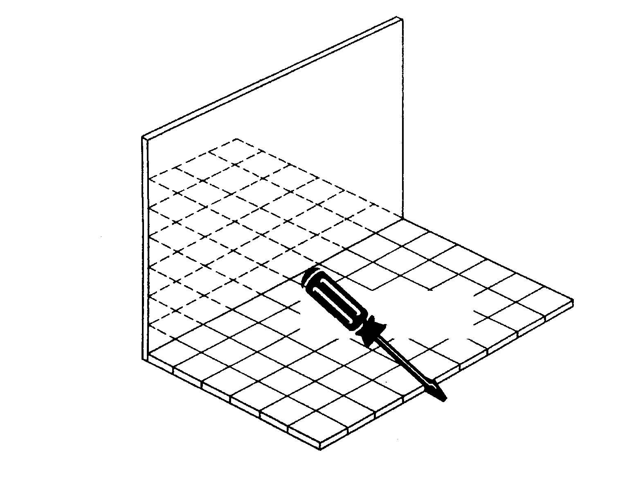

object

On the diagram draw what would be seen in the mirror.
- List three uses of concave mirrors.

___________________________________________________________________________________________________________________________________________________________________________________________________________________________________________________

- Convex mirrors are often found at the back of 7 – eleven shops.
Why are convex mirrors used for this purpose?

___________________________________________________________________________________________________________________________________________________________________________________________________________________________________________________

EXPERIMENT 4: REFRACTION IN WATER

Aim
To observe refraction in water.

Equipment
- Beaker,
- Coin
- pencil
- Beaker (opaque) or evaporating dish

Method
- Place a pencil in a nearly full beaker. Explain what you observe.

___________________________________________________________________________________________________________________________________________________________________________________________________________________________________________________

- Place a coin in an empty beaker (opaque) so that you just can’t see the edge of the coin as in the diagram.


Slowly pour water into the cup, making sure you
don’t disturb the coin as you do so. What do
you observe?

___________________________________________________________________________________________________________________________________________________________________________________________________________________________________________________

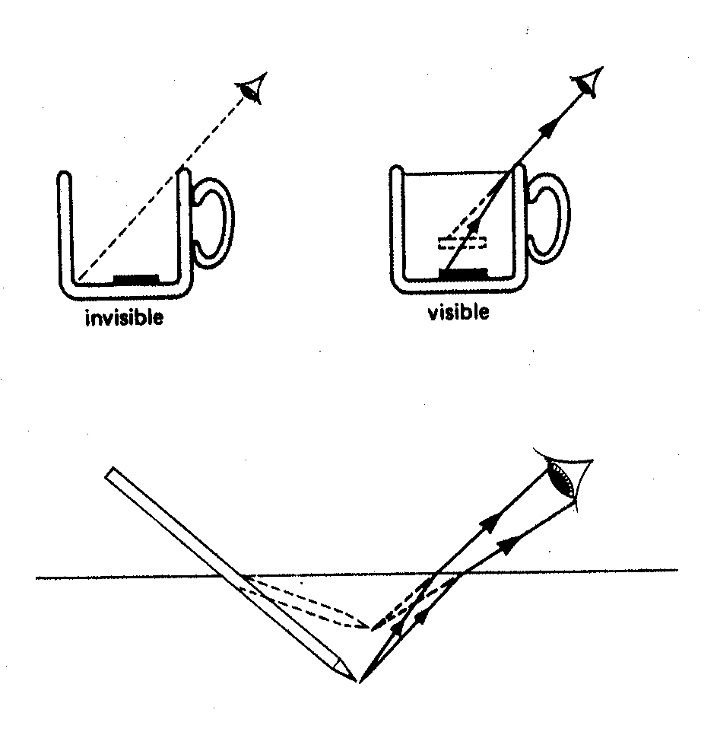
Explanation

The following diagrams may help you understand what was taking place.

Write a few sentences, in your own words, to describe the process of refraction (you might want to refer to page 329-330 of Science Quest 9 to help you

EXPERIMENT 5: REFRACTION IN PERSPEX

Aim
To investigate the refraction (bending) of light as it passes from one medium into another.

Equipment
- Light box
- Single Slit
- Power packs
- Semi-circular prism

Method

- Using the ray box, produce a single narrow beam of light.
- Place a semi-circular perspex (plastic) shape on the diagram on the next page.
- Direct the narrow beam of light on the 10° line on the ‘angle of incidence’ side, so that the ray of light strikes the semi circular prism at a right angle (90°).
- Note carefully what happens as the ray of light leaves the perspex block, and record the angle of refraction in the table below. Remember that we measure the angles between the ray and the normal. Draw carefully the rays of light (both incidence and refraction) and label them both (1).
- Repeat this process for angles of 20°, 30° and 40°. Take all measurements very carefully.

Results

Record your data in the table below

Angle of Incidence (°) | Angle of Refraction (°)

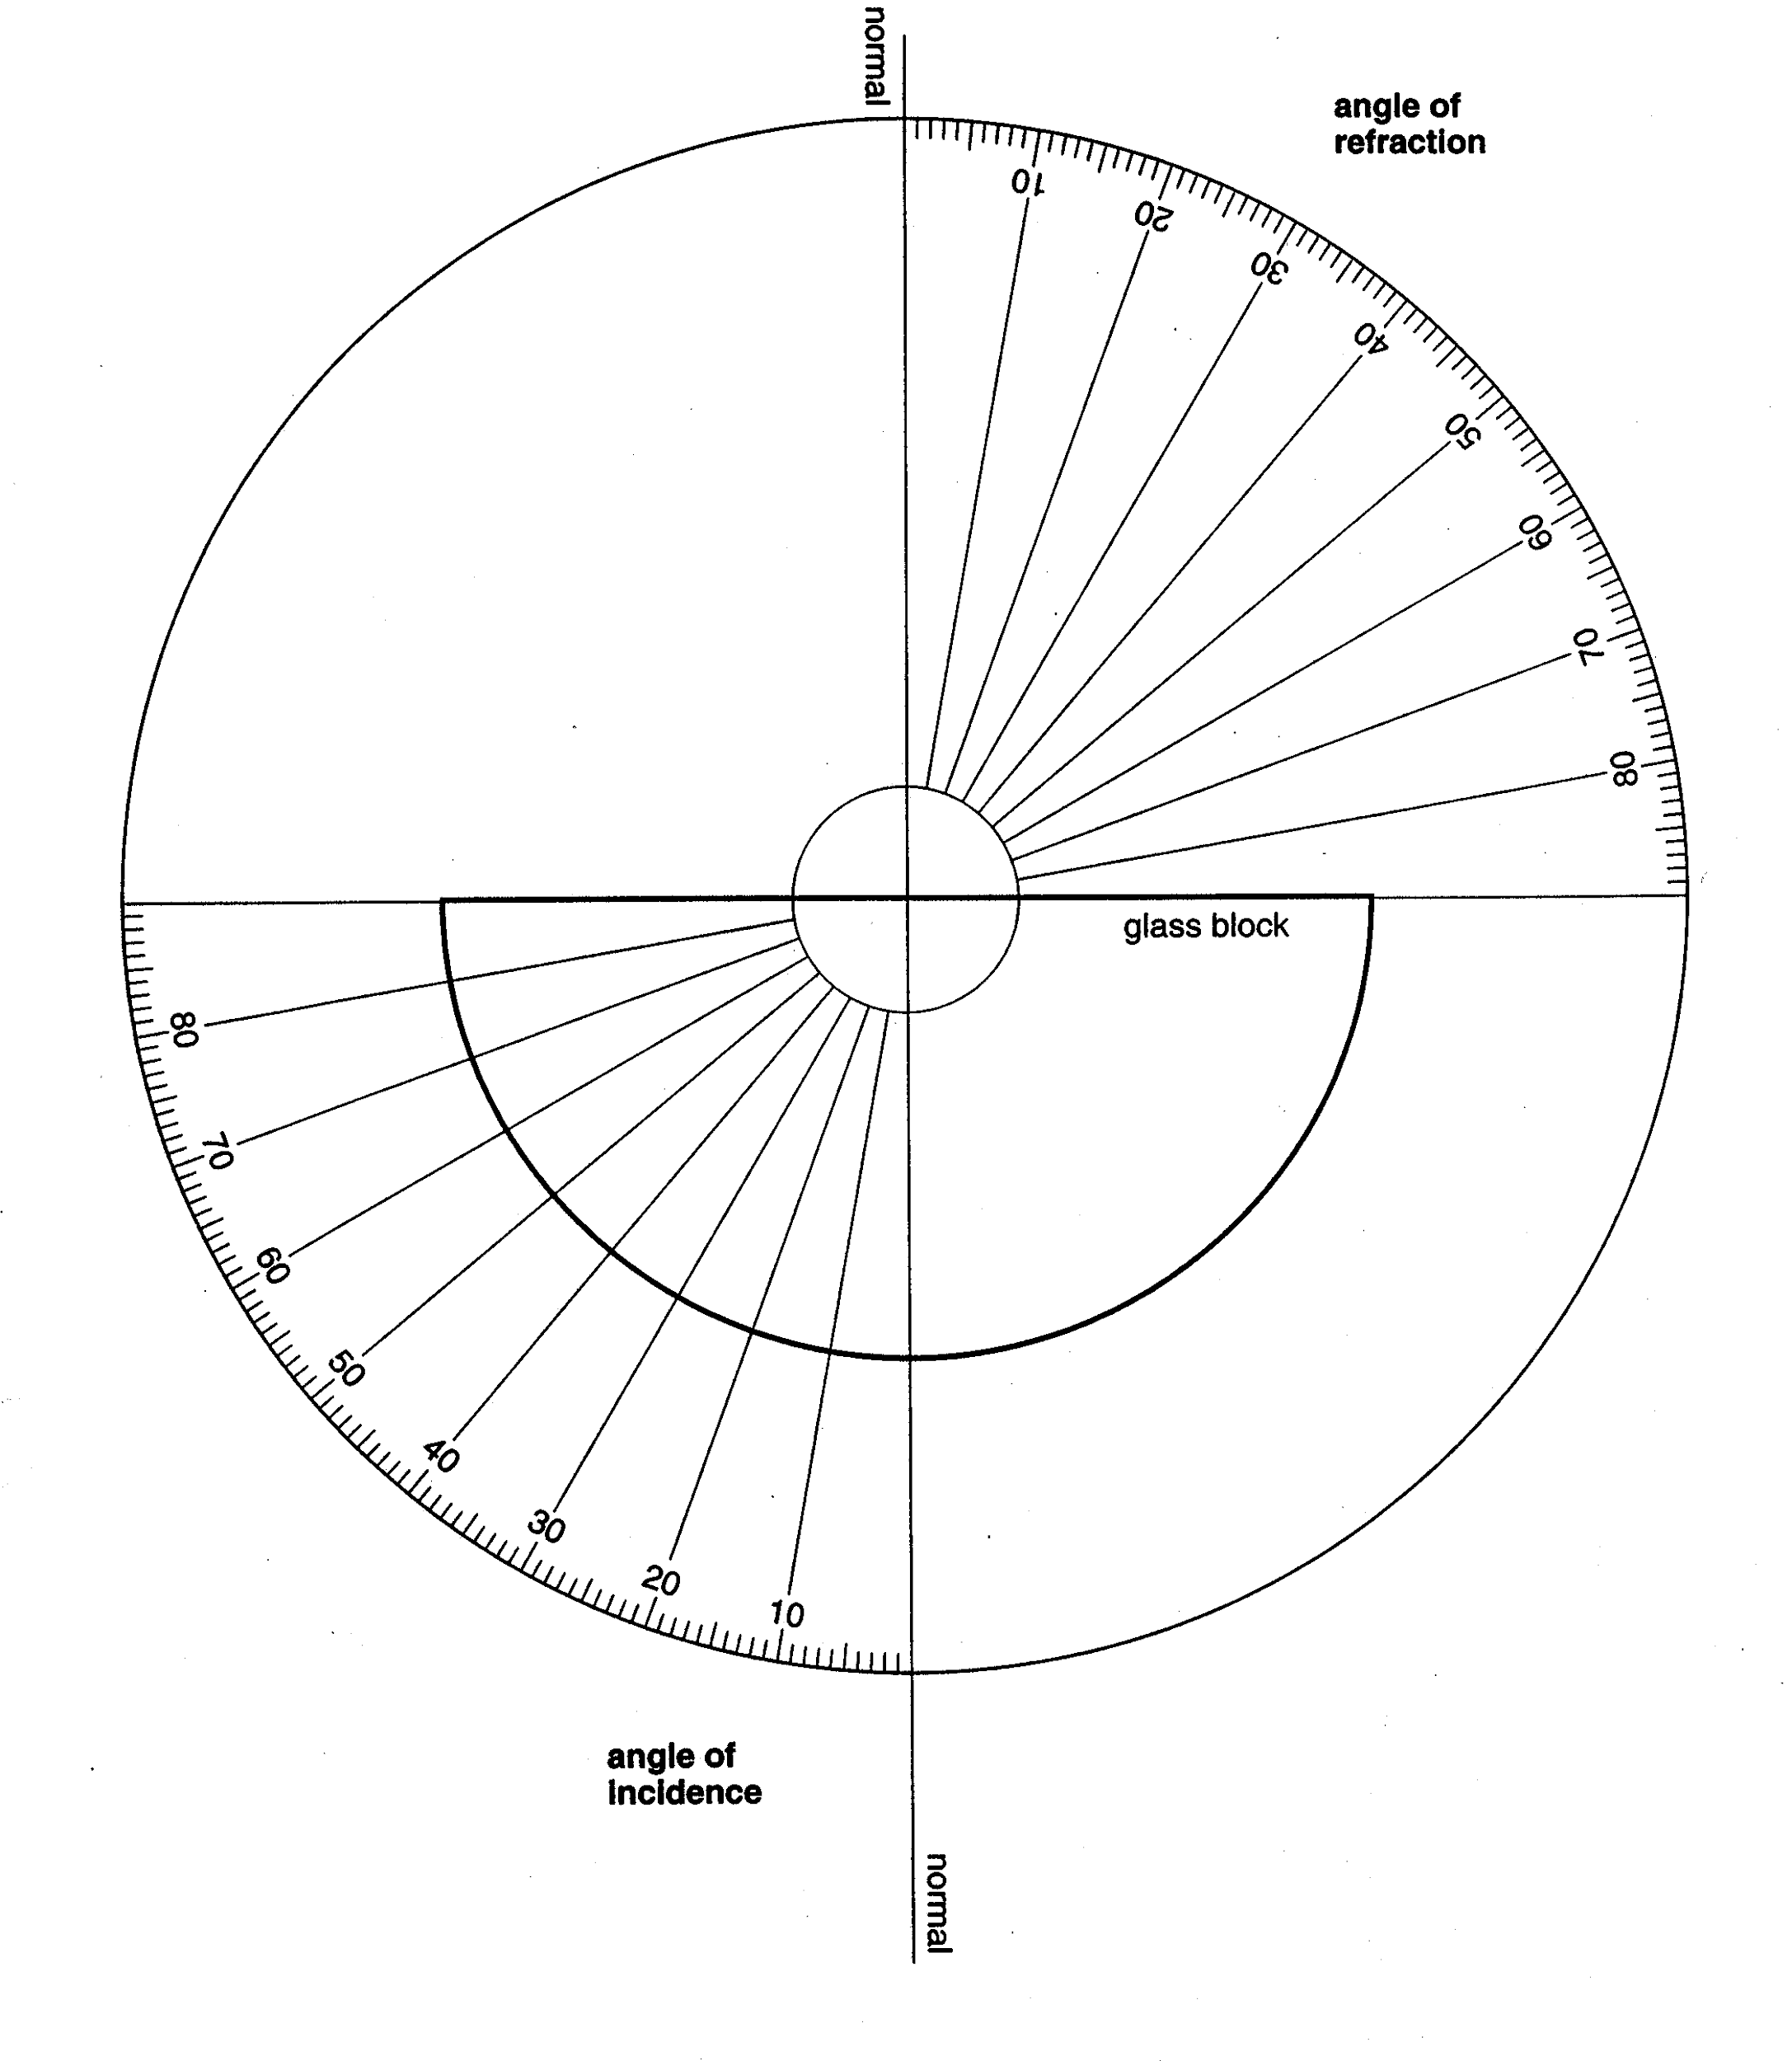
Results continued

Now draw up a second table in the space below to record the sin of the angles of incidence and refraction. Add another column to record the sin of the angle of incidence divided by the sin of the angle of refraction (i.e. sini/sinr).

Graph sin i v. sin r. Determine the gradient of the line of best fit .

The gradient of the graph of sin i v. sin r is called the refractive index. The theoretical refractive index of perspex is around 1.5.

How close was your value to the expected value? What are some sources of error in your experiment?
___________________________________________________________________________________________________________________________________________________________________________________________________________________________________________________
Questions

- What did you notice about the angle of refraction compared with the angle of incidence for each of the four trials?

___________________________________________________________________________________________________________________________________________________________________________________________________________________________________________________

- Which substance is denser, the Perspex block or air?

_________________________________________________________________________________

- At which boundary, air → Perspex or Perspex → air where we investigating refraction?

_________________________________________________________________________________

- In the experiment we were investigating light going from one medium to another. Complete the sentence below that outlines what was taking place.

As light travels from _____________ to _____________, the ray of light bends _____________ the normal.
The results show that when light travels from _____________ dense to _____________ dense, the light will bend (refract) _____________ the normal.
- If light were to travel from a less dense into denser medium, what do you expect would happen?

_________________________________________________________________________________
_________________________________________________________________________________

Conclusion

____________________________________________________________________________________________________________________________________________________________________________________________________________________________________________________________________________________________________________________________________
REFRACTION
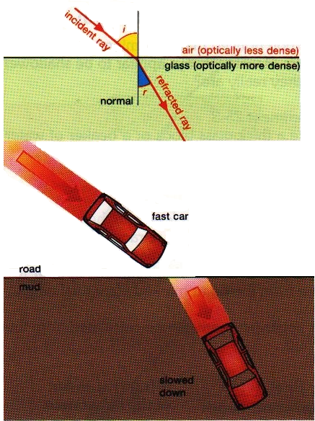
Refraction is the ‘bending’ or change in direction of light (or any wave for that matter) as the light travels from one medium into another.

We have seen refraction as light passes from a denser medium into a less dense medium (Perspex → air).

Refraction can be likened to a car travelling along a road and then crossing into some mud. As the front drivers wheel of the car contacts the mud, it slows down. However, the other front wheel will continue at the same speed. This causes the car to change direction.

In the above example, the car travels slower in mud than on the road. As this decrease in speed occurs, the change in direction occurs such that the direction of the car moves closer to the normal.

In summary

Rays of light travelling from less dense mediums to more dense mediums will be refracted ____________ the normal.

Rays of light travelling from more dense mediums to less dense mediums will be refracted ____________ the normal.

Normal

Air
Glass

Air
Glass

WORKSHEET # 4

- Complete the following diagrams showing the path of light as it travels from one medium to another.

Air

Glass
Water

Air

- The diagram shows a glass block. Two light rays are hitting the glass block at different angles.

Complete both diagrams, showing the path of the light through both prisms.

Describe how the speed of the wave changes in the diagrams that you have drawn.

_____________________________________________________________________

State what causes the speed of the wave to change as it enters the glass block.

_______________________________________________________________
EXPERIMENT 6: LENSES

Aim
To investigate two dimensional lenses.

Equipment
Light box, power pack and lenses

Method & Results
Find the resulting beams when the following lenses (prisms) are used. Draw your results accurately.

1. 2.

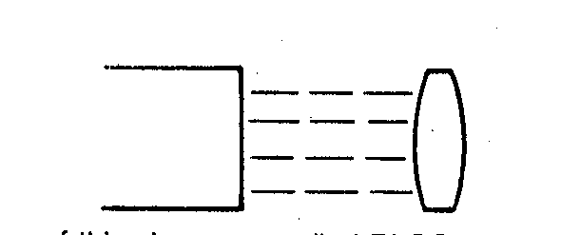
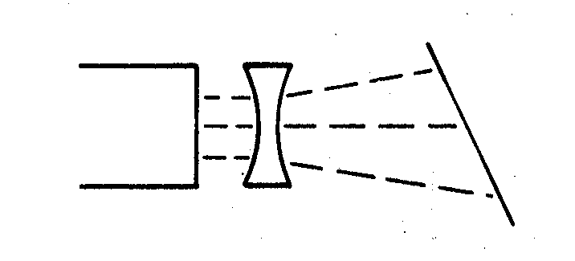
Lens 1 Lens 2

Questions
- Write down the names of the lenses underneath them.
- Mark in the focus in the lens 2.
- What is the focal length (in mm) of lens 2?
- What do you think would happen to the focal length if the lens 2 is made thicker?
__________________________________________________________________________________________________________________________________________________________________
5. Lens 1 has a focal point too. Where do you think it is? Mark it in if you know.

Conclusion

___________________________________________________________________________________________________________________________________________________________________________________________________________________________________________________

EXPERIMENT 7: LENSES 2

Aim
To investigate the images that can be produced with lenses

Equipment
Concave Lens
Convex Lens

Method

- Take a concave lens and look at an object through the lens. Hold the lens about 10 cm from the object.

Is the image larger or smaller than the object? ________________________
Is the image upright or inverted? ________________________
Is the image real or virtual? ________________________

Now hold the lens about 10 cm away from a piece of paper and try focus the image of the window onto the paper. Can you do this?

- Take a convex lens and look at an object through the lens. Hold the lens about 10 cm from the object.

Is the image larger or smaller than the object? ________________________
Is the image upright or inverted? ________________________
Is the image real or virtual? ________________________

Now hold the lens about 10 cm away from a piece of paper and try focus the image of the window onto the paper. Can you do this? Comment. __________________________________________________________________________________________________________________________________________________________________

Conclusion

___________________________________________________________________________________________________________________________________________________________________________________________________________________________________________________

TOTAL INTERNAL REFLECTION

We have seen how light can bend as it moves from one medium to another. It was also mentioned previously that light bends away from the normal as it moves from a more dense medium to a less dense medium. Let us consider this situation for a moment.

As an example, imagine light travelling from water into air.

air

water

We expect the light ray to be refracted away from the normal and we are NOT disappointed. But if we continue to increase the angle of incidence, the angle of refraction will also continue to increase. In fact, eventually the angle of refraction will be 90°.

air

^{90°}
water

When this occurs, the light is not refracted, but is TOTALLY INTERNALLY REFLECTED. (T.I.R.)
Refraction of the light into the air does not occur.

air

water
i r

Some reflection still occurs.

The light is not refracted into the air, but is reflected back down into the water. The angle of incidence that causes this is called the CRITICAL ANGLE, and has the symbol i_{c} . Whenever the angle of incidence is equal to or greater than the critical angle, total internal reflection will occur. When the light is totally internally reflected, it does so with i = r.

WORKSHEET # 5
EXPERIMENT 8:DISPERSION

Aim
To investigate the dispersion of white light as it passes through a triangular prism.

Equipment
- Light box
- Single Slit
- Power packs
- Triangular (equilateral) prism
- White screen

Method

Set up the following apparatus.

Ray Box

White screen

- Adjust the position of the ray box until you observe colours on the white screen.

Results
Draw a clear diagram of your results, accurately recording the colours that you observe on white screen.

Conclusion

___________________________________________________________________________________________________________________________________________________________________________________________________________________________________________________

DISPERSION

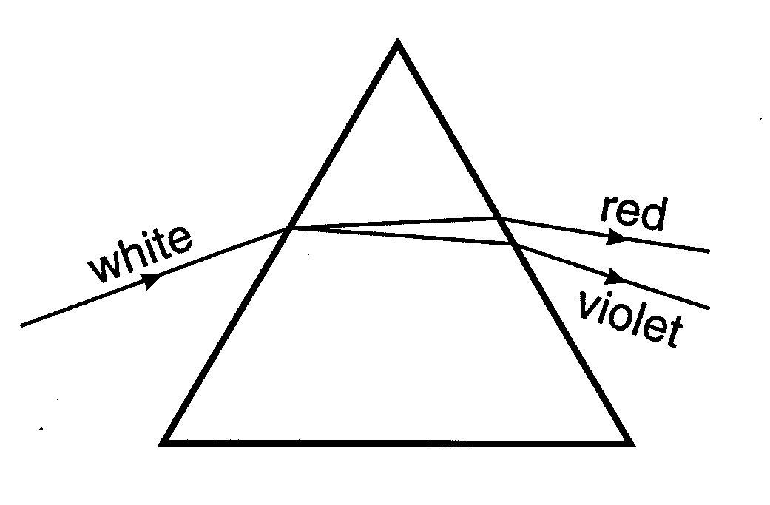
White light is a mixture of several colours and these can be split up using a prism. When this occurs, we say that the white light has been dispersed. The order of the colours is always the same, with red light being deviated (refracted) the least and violet light being deviated (refracted) the most.

The order of the colours is Red, Orange, Yellow, Green, Blue, Indigo and Violet.

(R O Y G B I V)

Sir Isaac Newton was the first scientist to undertake this simple experiment.

The colours of the rainbow are produced by refraction of sunlight in individual raindrops.

Dispersion occurs because different colours of light have different wavelengths. Red light has a larger wavelength than violet light. When white light enters a prism, the colours of white light all slow down, but by differing amounts. Violet is slowed down the most and red the least.
EXPERIMENT 9: COLOUR

Coloured light behaves differently to coloured paint, in terms of mixing colours. The primary colours of light are red, green and blue.

Aim
To investigate the colours that can be produced by mixing the primary colours of light.

Equipment
- PHET Colorado – Color Vision

Part 1: Single Bulb
- Select the ‘single bulb’ simulation. Click the red button on the flashlight to turn it on. The color in the thought bubble represents the color that the person sees in their mind. Take a minute or two and see what the two sliders do and the button on the arm coming out of the bottom thing.
- What does the person see if you put red light through a red filter? _________________
- What does the person see if you put violet light through a red filter? __________________
- What does the person see if you put violet light through a violet filter? _________________
- Experiment with the colors of filters and lights. Do the filters ‘filter out’ the color they are or the other colors? Explain.

- Switch the flashlight to white light by clicking the white bulb above the flashlight.
- See what different filters do to the light seen by the person when the light source is white. Are there any colors you can’t see using white light and a colored filter? Explain.

Part 2: RGB Bulbs
- Click the ‘RGB Bulbs’ part of the simulation at the bottom. Spend a minute or two playing around with this and familiarizing yourself with the controls.
- The light appears to be tiny particles. Think back to our notes (or look at them if you need to). What do we call light as a particle? __________________________
- Turn red, green, and blue all the way up. What color is seen? ______________________
- Turn red, green, and blue all the way down. What color is seen? ______________________
- Turn green and blue to 100% and turn red to 0%. What color is seen? __________________
- Turn red and green to 100% and turn blue to 0%. What color is seen? __________________
- Turn red and blue to 100% and turn green to 0%. What color is seen?___________________
- Turn all three to about 50%. What color is seen? ______________________
- Turn all three to about 25%. What color is seen? ______________________
- How are the colors form #14 and #15 similar but different? Why do you think this is so?

- Do your best to mix up a mint green. About what percent is each color when you achieve this?
R = ___________________ G = ____________________ B = ____________________
- Do your best to mix up orange the color of the fruit. About what percent is each color when you achieve this?
R = ___________________ G = ____________________ B = ____________________

Conclusion

___________________________________________________________________________________________________________________________________________________________________________________________________________________________________________________
___________________________________________________________________________________________________________________________________________________________________________________________________________________________________________________

COLOUR

We have seen how white light can be split into its constituent colours. (Remember that this process is called dispersion and the colours can be represented by ROYGBIV). The opposite effect can also be created. In other words, combining colours together can produce white light. If red, green and blue are combined together, then white light is produced. Red, green and blue are the primary colours of light. How does this work? The red primary colour of light is obtained by taking about a third of the light at the red end of the spectrum and blending it together. The blue primary is a blend of about a third of the spectrum at the blue-indigo end of the spectrum, and the green primary light is a mixture of the middle part of the spectrum. Because of this fact, the primary colours of light are slightly different to the primary colours that artists use.

If you combine red and green light together, yellow light is produced. Yellow light and blue light together will make white. (Because this is a combination of the three primary colours of light.) This process is called an additive one. Therefore, yellow light is called the complementary colour to blue.

 | Color Mixture | Resultant Colour | Complementary Colour
 | red + green | yellow | blue
 | blue + green | cyan | red
 | red + blue | magenta | green

A colour television uses the primary colours of light to produce all of the colours that we see on the screen.

SECTION | COLOR PRODUCED

A

B

C

D | GREEN LIGHT  B  BLUE LIGHT  RED LIGHT  D  A  C
WORKSHEET # 6

- Complete the following:

White light is composed of ____________ colours, in order: red, ____________, ____________, ____________, ____________, ____________ and ____________. These colours form the visible ____________. The colour with the longest wavelength is ____________. The colour deviated through the largest angle by a prism is ____________.

Visible light is only one part of the larger ____________ spectrum. In order, this is gamma-rays, ____________, ____________, visible light, ____________, ____________, ____________ and radio waves. The section with the longest wavelength is ____________. The most dangerous to humans is ____________.

The three primary colours of light are ____________, ____________ and ____________. When added together, these three colours produce ____________ light.

- The diagram shows white light being dispersed by a prism.

White light
X

Y

a) What colour would you see at i) X ____________
ii Y ____________

- Complete the following table:
COLOURS OF LIGHT ADDED TOGETHER | APPEARANCE
Red and Green and Blue
Red and Green
Red and Blue
Blue and Green
Blue and Yellow

